Day 17 - 07th Aug 2026

Task 1:
What is data binding?
9.36 to 9.40

Task 2:
What do you understand by one way data binding and two way data binding?
9.41 to 9.45

Task 3:
When do you use one way data binding and when to use two way data binding?give examples.
9.46 to 9.50

Task 4:
What is the state in react?
9.51 to 9.54

Task 5:
Can you explain SPA?
9.55 to 10.00

Task 6:
What is DOM?
10.01 to 10.03

Task 7:
What is virtual DOM?
10.04 to 10.08

Task 8:
What are props in react ? can you explain about prop drilling?
10.09 to 10.12

Task 9:
Why do we use react?give importance and describe in detail.
10.13 to 10.18

Task 10:
What do you understand by component based architecture?
10.19 to 10.25

Task 11:
Explain lifecycle of react component with diagram.. Describe mounting , unmounting etc ..
10.26 to 10.33

Task 12:
What are Hooks in react?why use hooks- importance ? What are different types of hooks?
1034 to 10.44

Task 13:
What is react redux architecture ?explain in detail.
10.45 to 10.50

Demo1:

10.52 to 11.07 break..

Step 1:

Create the root app —> app.jsx – with h1 tag in the function app
And export it..

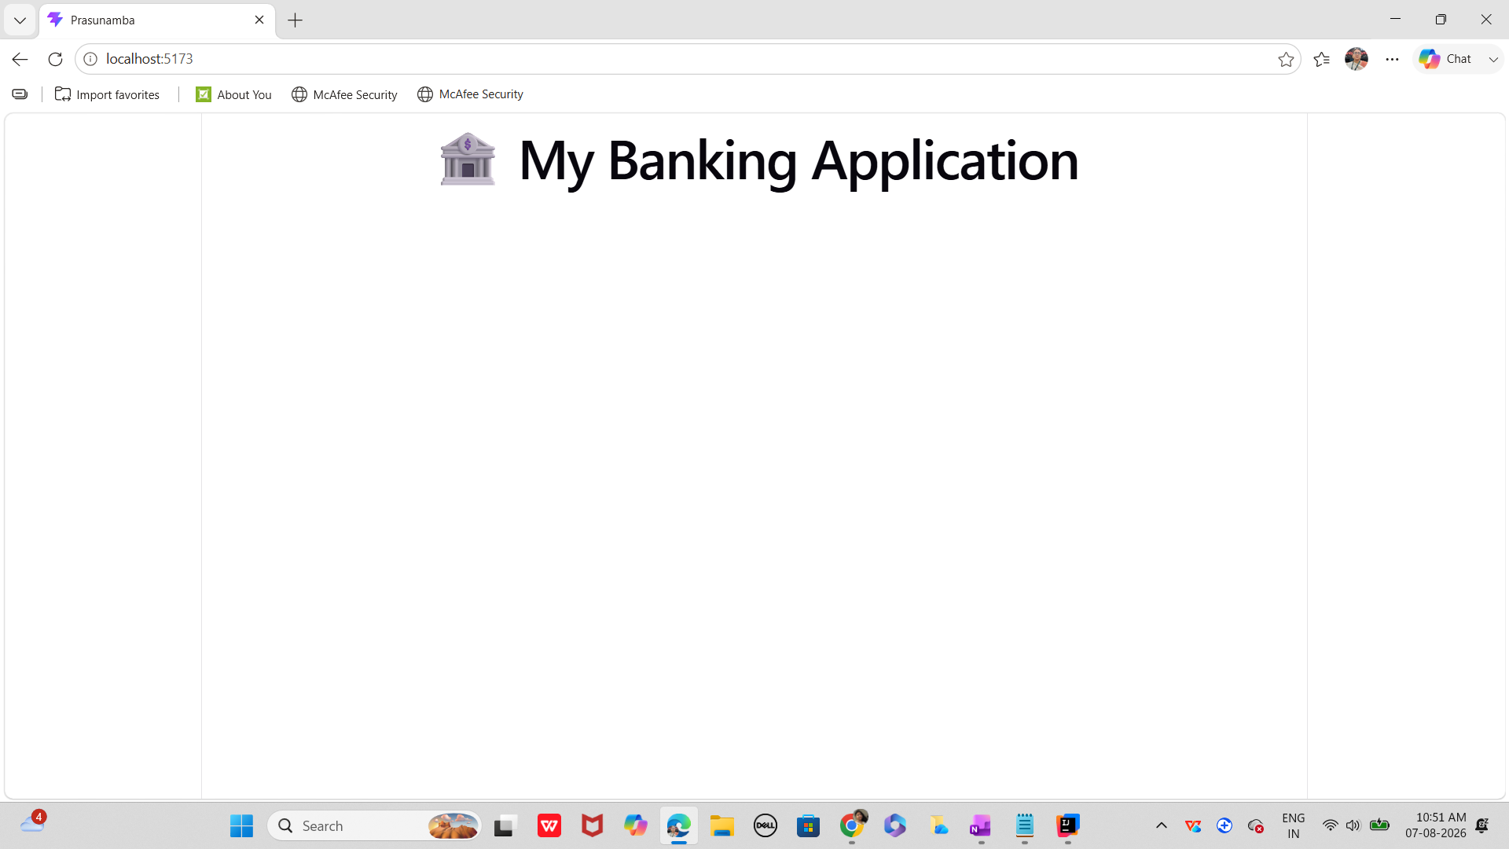

Step 2:
In src..
Create a components folder and add a function component.

Like dashboard.jsx

Step 3:
In components/ create Accounts.jsx

Step 4:

Create a usestate … initialize and use it to display the current balance

Import useState hook

import React, { useState } from "react";// react hook - usestate

Initialize the useState

const [balance, setBalance] = useState(1000);

// Handle new transaction
const handleTransaction = (type, amount) => {
let newBalance = balance;
if (type === "Deposit") newBalance += amount;
if (type === "Withdraw") newBalance -= amount;
setBalance(newBalance);

Step 4:

Conditional rendering like
Balance <0 —>

{balance < 0 && <p style={{ color: "red" }}>⚠️ Overdraft Alert!</p>}

Step 5:

In components / create TransactionForm.jsx

Now
Step 6:
Can you implement use state hook in TransactionForm.jsx
For setAmmount
Set Type → deposit.. Or so

Step 7:
Use the concept of prop drilling

Ex: prop drilling… from APP →parent → child → grand child.. Any connection break will lead to disturb prop drilling..
Note: If you add more nested layers, the chain grows longer.
Refactoring becomes painful because every layer is tied to the prop.

function App() {
const user = "Prasunamba";
return <Parent user={user} />;
}

function Parent({ user }) {
return <Child user={user} />;
}

function Child({ user }) {
return <GrandChild user={user} />;
}

function GrandChild({ user }) {
return <p>Hello {user}</p>;
}

Finally the output

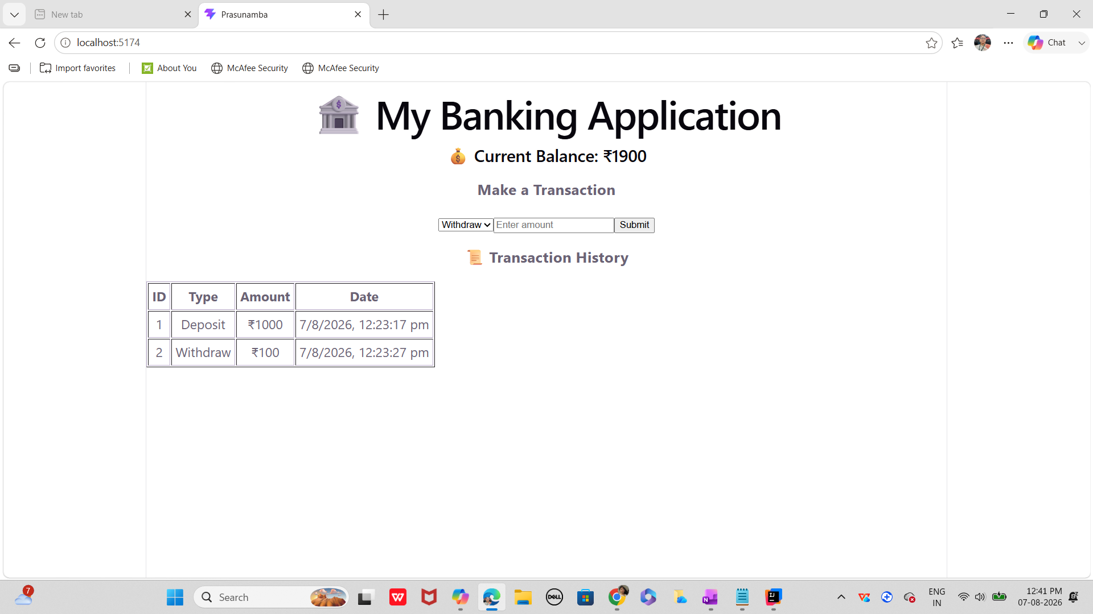

Step 8:

As you have already implemented state hooks..

Eg :useState - -> Declares a state variable and updater function.

const [count, setCount] = useState(0);

Can you try to implement one more state hook .. useReducer?

Like eg:
useReducer -> → Manages complex state logic with a reducer function.

const [state, dispatch] = useReducer(reducer, initialState);

Step 9:

Effect Hooks:

useEffect → Handles side effects (API calls, subscriptions, DOM updates).
Like example
useEffect(() => {
document.title = `Count: ${count}`;
}, [count]);

Step 10:
useLayoutEffect → Runs before the browser repaints (for layout measurements).

useInsertionEffect → Used mainly by libraries to inject styles before DOM updates.

Step 11:
Use contextHooks:

useContext → Accesses values from React Context without prop drilling.

Like eg

const theme = useContext(ThemeContext);

Step 12:
Ref Hooks:

useRef → Stores mutable values (like DOM nodes or timers) without causing re-renders.

const inputRef = useRef(null);

Step 13:
Performance Hooks
useMemo → Memoizes expensive calculations.

useCallback → Memoizes functions to avoid unnecessary re-renders.

useTransition → Manages concurrent rendering for smoother UI.

useDeferredValue → Defers updating non-critical UI parts.

Step 14:
useId → Generates unique IDs for accessibility.

useDebugValue → Labels custom hooks for debugging.

=================================================
Juz fyi only:

App.jsx

import React from "react";
import Dashboard from "./components/Dashboard";
function App() {
return (
<div>
<title>Prasunamba </title>
<h1>🏦 My Banking Application</h1>
<Dashboard />
</div>
);
}
export default App

Account.jsx

import React from "react";
function Account({ balance }) {
return (
<div>
<h2>💰 Current Balance: ₹{balance}</h2>
{balance < 0 && <p style={{ color: "red" }}>⚠️ Overdraft Alert!</p>}
</div>
);
}
export default Account;
Dash board.jsx

import React, { useState } from "react";// react hook - usestate
import Account from "./Account";
import TransactionForm from "./TransactionForm";
import TransactionHistory from "./TransactionHistory";
function Dashboard() {
// State hooks
const [balance, setBalance] = useState(1000);
const [transactions, setTransactions] = useState([]);
// Handle new transaction
const handleTransaction = (type, amount) => {
let newBalance = balance;
if (type === "Deposit") newBalance += amount;
if (type === "Withdraw") newBalance -= amount;
setBalance(newBalance);
// Add to transaction history
const newTransaction = {
id: transactions.length + 1,
type,
amount,
date: new Date().toLocaleString(),
};
setTransactions([...transactions, newTransaction]);
};
return (
<div>
<Account balance={balance} />
<TransactionForm onTransaction={handleTransaction} />
<TransactionHistory transactions={transactions} />
</div>
);
}
export default Dashboard;

TransactionForm.jsx

import React, { useState } from "react";
function TransactionForm({ onTransaction }) {
const [amount, setAmount] = useState("");
const [type, setType] = useState("Deposit");
const handleSubmit = (e) => {
e.preventDefault();
if (!amount || amount <= 0) return alert("Enter valid amount");
onTransaction(type, parseFloat(amount));
setAmount("");
};
return (
<form onSubmit={handleSubmit}>
<h3>Make a Transaction</h3>
<select value={type} onChange={(e) => setType(e.target.value)}>
<option value="Deposit">Deposit</option>
<option value="Withdraw">Withdraw</option>
</select>
<input
type="number"
placeholder="Enter amount"
value={amount}
onChange={(e) => setAmount(e.target.value)}
/>
<button type="submit">Submit</button>
</form>
);
}
export default TransactionForm;

TransactionHistory.jsx

import React from "react";
function TransactionHistory({ transactions }) {
return (
<div>
<h3>📜 Transaction History</h3>
{transactions.length === 0 ? (
<p>No transactions yet.</p>
) : (
<table border="1" cellPadding="5">
<thead>
<tr>
<th>ID</th>
<th>Type</th>
<th>Amount</th>
<th>Date</th>
</tr>
</thead>
<tbody>
{transactions.map((txn) => (
<tr key={txn.id}>
<td>{txn.id}</td>
<td>{txn.type}</td>
<td>₹{txn.amount}</td>
<td>{txn.date}</td>
</tr>
))}
</tbody>
</table>
)}
</div>
);
}
export default TransactionHistory;

